Software engineering for big data analaysis

CSA-1035

EXP NO:- 16

16. draw an Activity diagram for the Online Shopping system using CASE tools with standard steps like Login, Search, Browse, add to cart, edit cart, delete cart, confirm purchase, make payments, and receive items, rate website login and logout on the system.

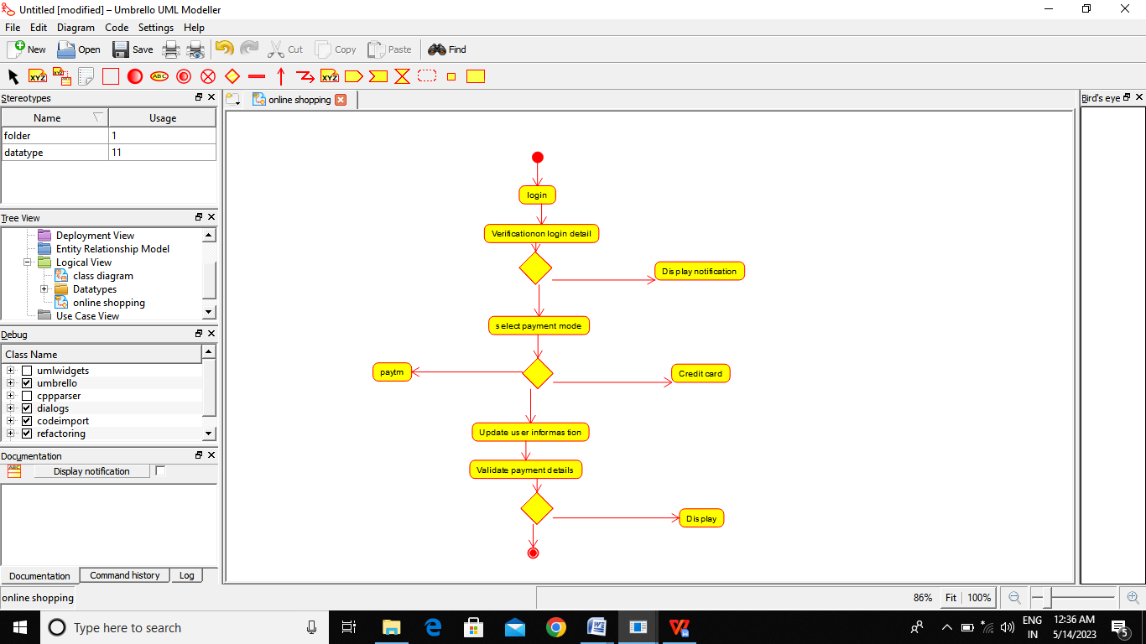

RESULT:-

Thus the Activity diagram for online shopping is drawn and verified successfully